**Student Management System - Final Project Report**

**Team Members:**

1. Nadine Aurellya Menno Bire/001202400060
2. Nailha Sakhila Dewi / 001202400021
3. Made Mas Pradnya /001202400038

**Tools Used:**

* Java (Swing GUI)
* NetBeans IDE
* MySQL Workbench (for database design & query)
* GitHub (version control & project submission)

**Project Overview:**

The Student Management System (SMS) is a desktop application built in Java (Swing) and MySQL. It helps in keeping student records, assigning courses on a semester basis, adding course grades, and calculating GPA. The system was created to simplify data entry and tracking of the students, especially for academic performance and report generation. This project is a submission of our final OOVP group assignment.

**Main Features:**

**1. Student Management:**

* Add new students with name, date of birth, gender, religion, email, phone, parents' name, address, and profile picture.
* Edit and delete existing student records.
* Display student list using JTable.

**2. Course Assignment:**

* Assign up to 8 courses for each student based on the selected semester.
* Validate no duplicate semester/course combination.

**3. Score Input & GPA Calculation:**

* Input score for each course (0.0 to 4.0 scale).
* Validate that score is within the allowed range.
* Automatically calculate GPA based on 8 course scores.
* Update or delete scores.

**4. Mark Sheet Generation:**

* Display student scores and GPA in a formatted table.
* Print student mark sheet using JTable’s built-in print feature.

**Database Design:**

1. **Table: student**

| **Field** | **Type** |
| --- | --- |
| id | INT (PK) |
| name | VARCHAR |
| dob | DATE |
| religion | VARCHAR |
| gender | VARCHAR |
| email | VARCHAR |
| phone | VARCHAR |
| father | VARCHAR |
| mother | VARCHAR |
| address | TEXT |
| image_path | TEXT |

1. **Table: course**

| **Field** | **Type** |
| --- | --- |
| id | INT (PK) |
| student_id | INT (FK) |
| semester | INT |
| course1 .. course8 | VARCHAR |

1. **Table: score**

| **Field** | **Type** |
| --- | --- |
| id | INT (PK) |
| student_id | INT (FK) |
| semester | INT |
| course1 .. course8 | VARCHAR |
| score1 .. score8 | DOUBLE |
| average | DOUBLE |

**Screenshots**

1. **Login Page with Show/Hide Passwor**

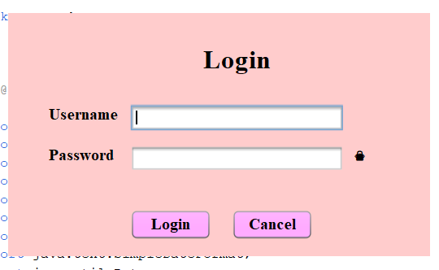

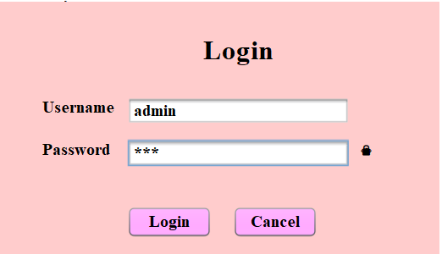

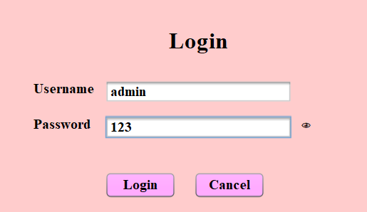

1. **Add Student Form**

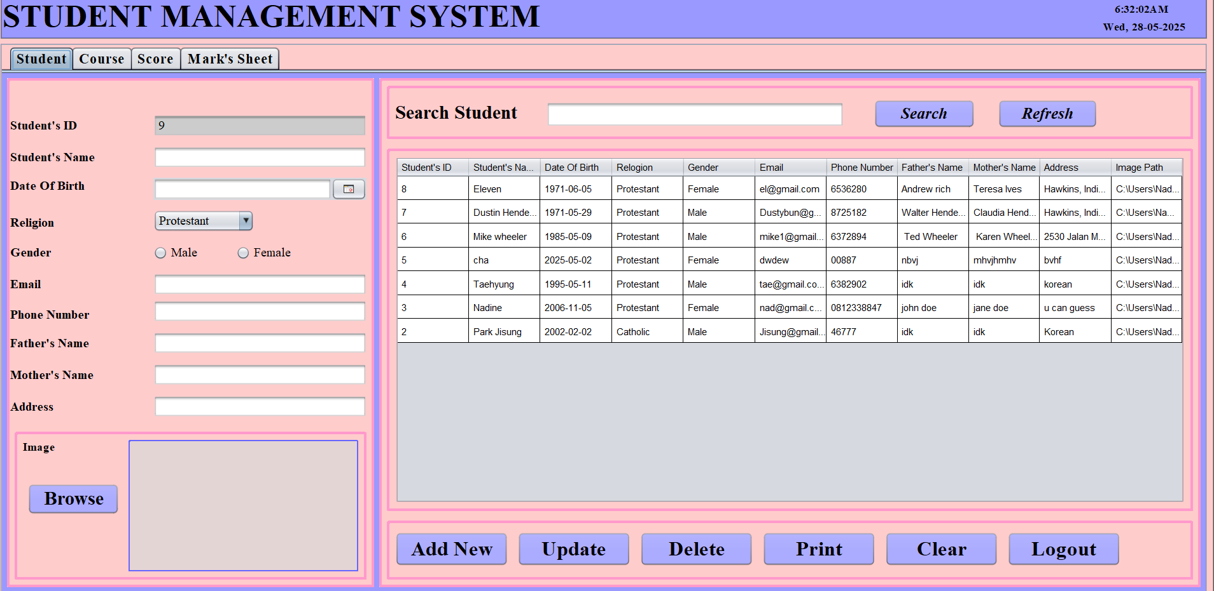

1. **Add Course Form**

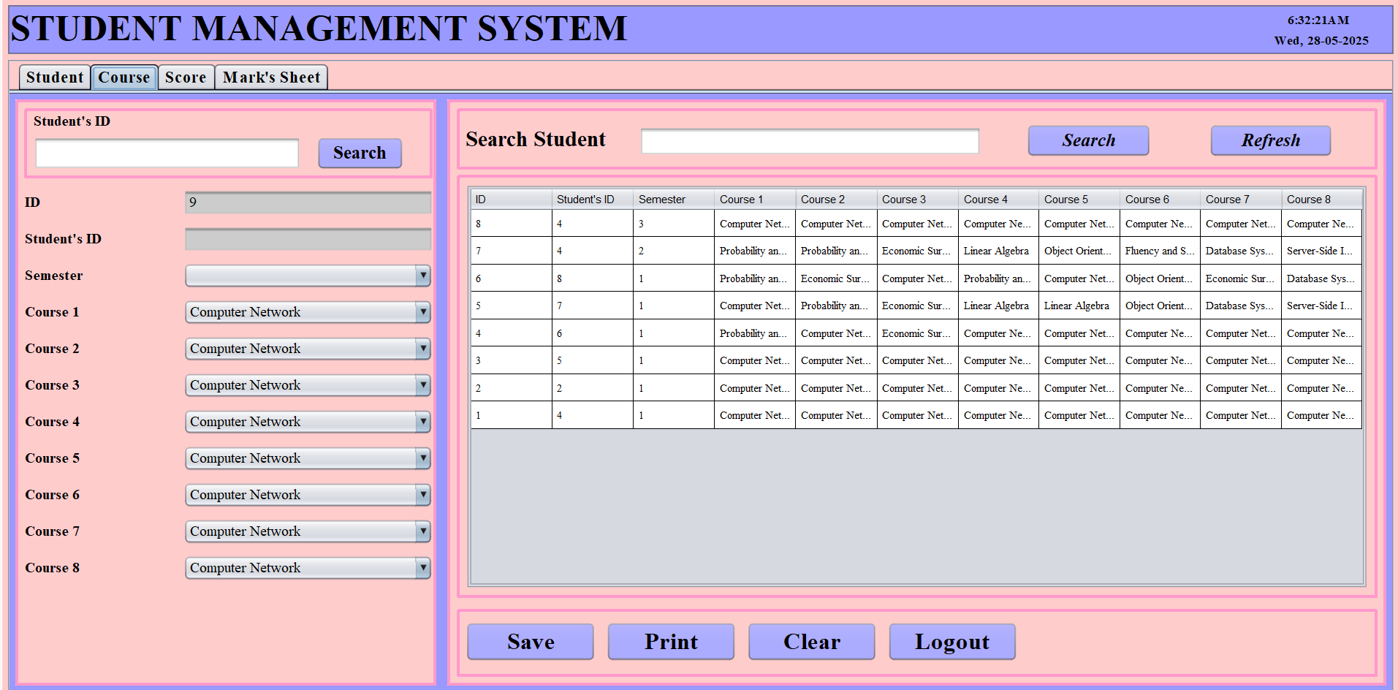

1. **Add Score Form**

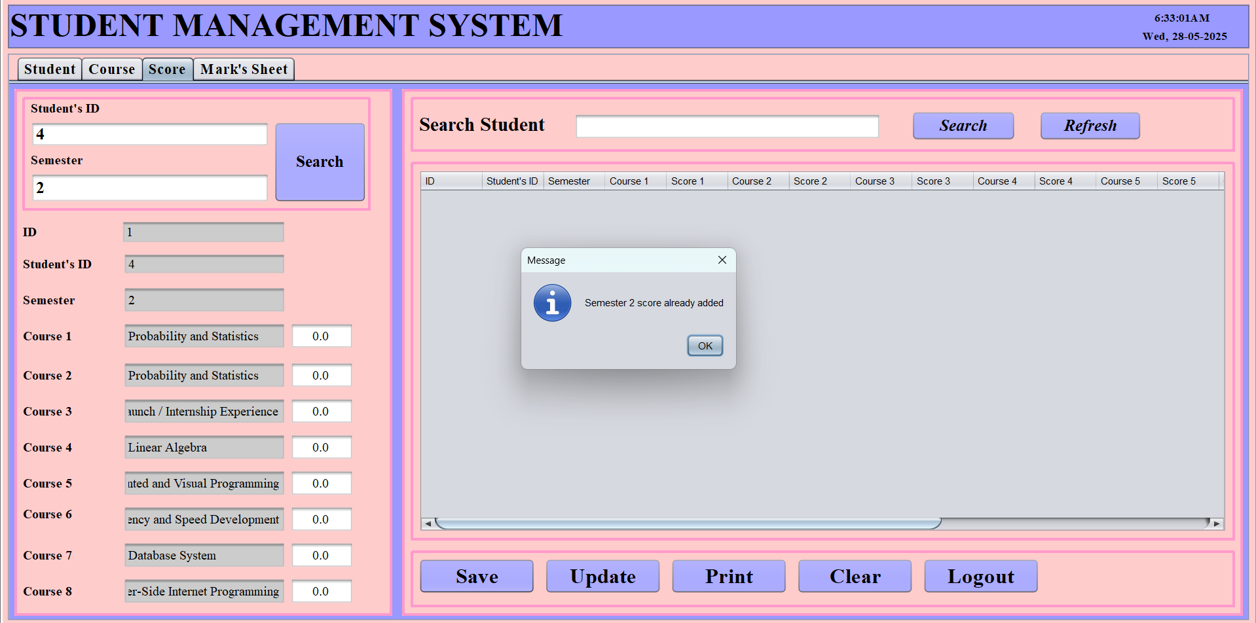

1. **View Mark Sheet**

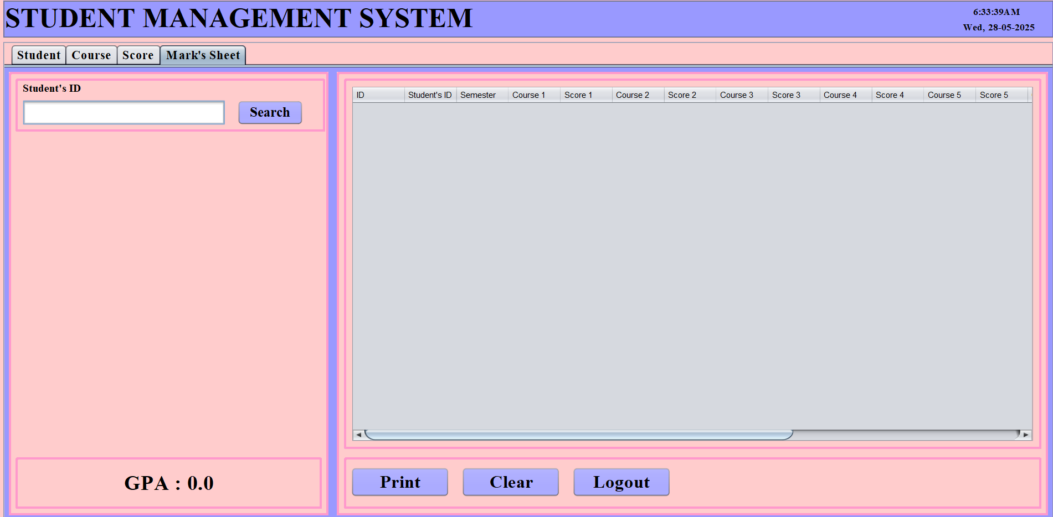

**CONCLUSION**

This system successfully implements a complete student record and GPA tracking application using Java Swing and MySQL. It includes image upload, score validation, and simple report printing. All features are divided clearly by modules, and the UI is user-friendly. The source code and report are now available in our GitHub repository.

**GitHub Repository**

<https://github.com/nadine6126/Student_Management>